Chapter IV
METHODOLODY OF THE WORK
This chapter is written to clarify all the steps of the work and the approach considered to reach the purpose mentioned in the previous chapters. The procedure starts with choosing and loading the humanoid in a real physics simulator and setting it in the environment to be evaluated under disturbances. The results will have to be extracted and assessed according to defined criteria which specify if the results are reasonable or not. After the validation of the results comes the collection of all needed results to be injected in a machine learning algorithm for the main purpose of force evaluation and localization will be achieved.

Virtual World Simulation
The first step of the of the work is to prepare a virtual simulation world in which all the experiments are going to conducted and all the measurements are going to be extracted. In this thesis Webots is used as a robot simulations software providing fast trial environment in a three dimensional world that is very similar to what is expected to be found in real life experiments with all physical properties taken into consideration such as the mass, the joints, the friction coefficients, contact surfaces and much more. All objects added in the simulation are added as nodes and each node can have one or more sub-node. The user can add simple passive objects or active objects called mobile robots. These robots can have different locomotion schemes (wheeled robots, legged robots, or flying robots). Moreover, they may be equipped with a number of sensor and actuator devices, such as distance sensors, drive wheels, cameras, motors, touch sensors, emitters, receivers, etc. Finally, the user can program each robot individually to exhibit the desired behavior.
All of what was mentioned above are tailored according to each simulation and its requirements but they should all be set in the Webots world which is the description of the properties of the robots with respect to each other and the environment along with a description of all objects’ position, geometry, orientation along with the physical properties and appearance. The world is saved with a “wbt” extension file in the “worlds” folder of the project in a workspace.
In this project, starting from an empty world the main node is the humanoid robot on which all the study in dependent and another node is the floor which is the contact surface or the ground on which the humanoid robot is standing. Other nodes are added such as the textured background and the texture background light just as additional display enhancement nodes although they have a major effect on other applications specially when it comes to light and shadows.
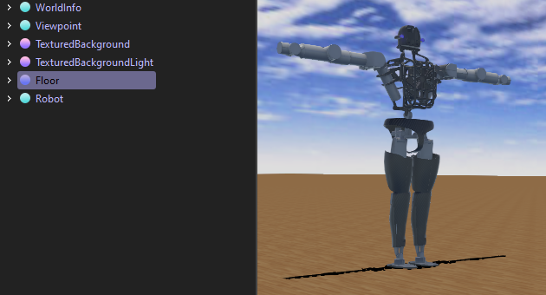
The node of highest importance in the humanoid robot. And in this thesis, Atlas was chosen to be the humanoid on which this study is going to be conducted since it is the one most complex and most advance humanoid robot developed nowadays. Webots offers a built-in node of Atlas humanoid robot which is developed by Boston Dynamics with funding and oversight from DARPA. The robot is 1.8 meters tall and is designed for a variety of search and rescue tasks. In Webots, Atlas is rendered with all its 28 joints set in the Scene Tree as parent and children links and joints. Clicking on each join in the scene tree highlights the joint in the 3D simulation and on the Webots Cyberbotics website is also a simulation of Atlas in which all joints can be controlled like a mannequin to know each name belongs to which joint.

Table 1. Atlas Humanoid Joints Names
Parent Link | Number of Joints | Joints Names
Neck | 4 | - BackLbz  - BackMby  - BackUbx  - NeckAy
Left Arm | 6 | - LArmElx  - LArmEly  - LArmMwx  - LArmShx  - LArmUsy  - LArmUwy
Left Leg | 6 | - LLegKny  - LLegLax  - LLegLhy  - LLegMhx  - LLegUay  - LLegUhz
Right Arm | 6 | - RArmElx  - RArmEly  - RArmMwx  - RArmShx  - RArmUsy  - RArmUwy
Right Leg | 6 | - RLegKny  - RLegLax  - RLegLhy  - RLegMhx  - RLegUay  - RLegUhz

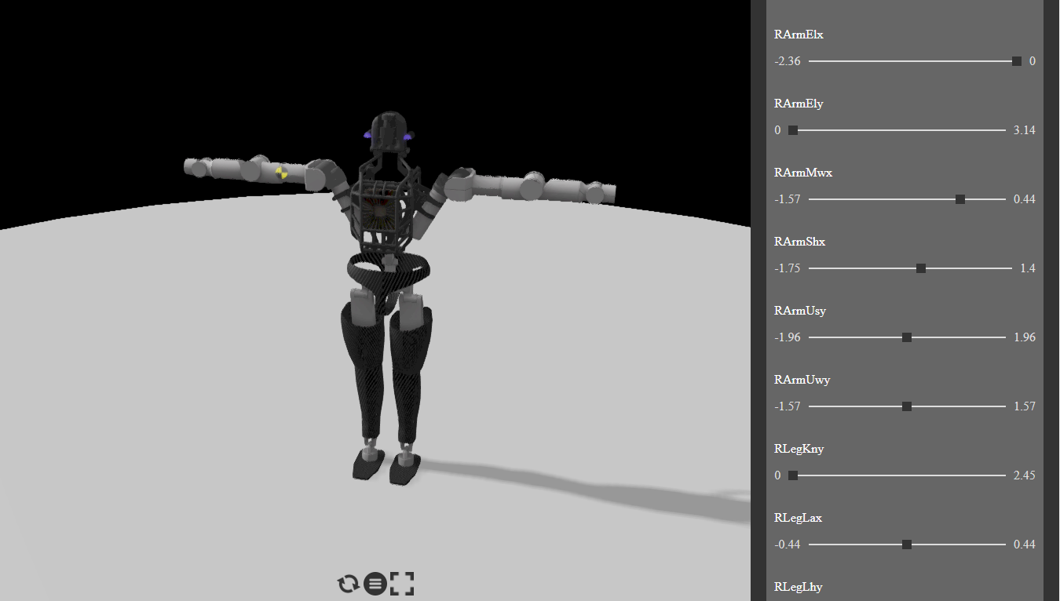
Figure 1. Atlas Joint Location and Control Mannequin

At this stage were all joints are defined, there should be an approach to be able to read the position $θ$ as it was referred to in the previous chapter, over a period of time t at specific joint. It is very essential to monitor $θ$ for all 28 joints because this actually describes how the humanoid is dynamically responding in function of time. So every time the response of the humanoid is to be monitored, 28 arrays are to be taken into account, which is $θ$ at each of the humanoid’s 28 joints . In Webots, at each of the 28 joint, in a Rotational Motor which will allow this humanoid to freely move about the predefined 28 degrees of freedom. Having motors, allow the extraction of the motor’s rotational speed and allows some other kind of motor control. But no information about the rotational position $θ$ can be extracted without adding a Position Sensor or a Rotary Encoder at each rotational motor along with giving each sensor a reference name tag. Respectively each position sensor at each joint was named after the joint add “_PS”. Taking the Joint BackLbz as an example, in the devices section a rotational motor is found along with a position sensor which was not originally found but added to it and named “BackLbz_PS”. It is also noticeable how BackLbz is a parent joint to two Children Joints LLegUhz and RLegUhz which are found in the endpoint solid section.

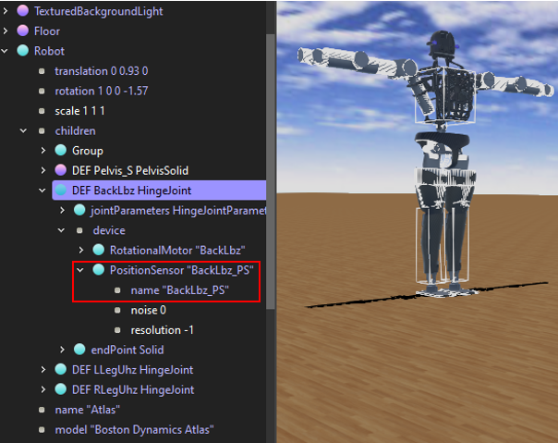
Figure 2. BackLbz Joint Details
One more additional step before creating the controlled which will be in charge of passing the instruction the robot and acquiring the data to be collected, the acceleration parameter at the motors of the robot is to be changed. If the acceleration parameter at the motor is kept -1 and the robot is subject to a disturbance, if the response at all joints is monitored, little is the difference. In other words, the effect of the force can hardly be detected or recognized due to the rigidity of the joints of the robot. Lowering the rigidity of the joints and keeping the robot more malleable, yield to results with remarkable changes due to different types of disturbances. The acceleration will become 0.15 which will keep the humanoid standing still and resistive to disturbances yet responsive. Fixing these settings yield to the evaluation of the humanoid with a better response under disturbances and also with the arms relaxed down instead of being extended.

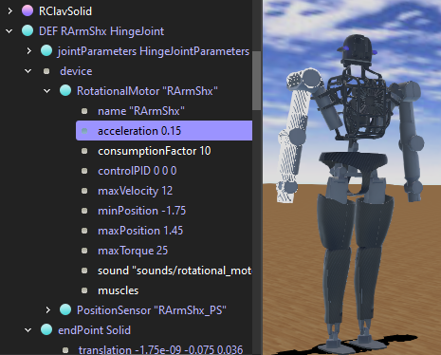
Figure 3. Motor Acceleration Parameter Settings

Data Collection

After setting the virtual world including all the needed nodes, adjusting the setting of each and fundamentally setting the reference names for all sensors and motors, it is at the stage that the controller should be created. A controller is a computer program that controls a robot specified in a world file. Controllers can be written in any of the programming languages supported by Webots: C, C++, Java, Python or MATLAB. When a simulation starts, Webots launches the specified controllers, each as a separate process, and it associates the controller processes with the simulated robots. Note that several robots can use the same controller code, however a distinct process will be launched for each robot. Some programming languages need to be compiled (C and C++) other languages need to be interpreted (Python and MATLAB) and some need to be both compiled and interpreted (Java). For example, C and C++ controllers are compiled to platform-dependent binary executables (for example ".exe" under Windows). Python and MATLAB controllers are interpreted by the corresponding run-time systems (which must be installed). Java controller need to be compiled to byte code (".class" files or ".jar") and then interpreted by a Java Virtual Machine. The source files and binary files of each controller are stored together in a controller directory. A controller directory is placed in the "controllers" subdirectory of each Webots project.
In this thesis, MATLAB is chosen as the programming language in which the controller will be written. This is because is it will be easier to save of acquired data in arrays and at later stage to form a dataset and evaluate it directly in MATLAB. MATLABTM is a numerical computing environment and an interpreted programming language. It allows easy matrix manipulation, plotting of functions and data, implementation of algorithms and creation of user interfaces. More information is available on the official MathWorks website. MATLAB is widely used in robotics in particular for its Image Processing, Neural Networks and Genetics Algorithms toolboxes. Webots allows to directly use MATLAB scripts as robot controller programs for simulations. Using the MATLAB interface, it becomes easy to visualize controller or supervisor data, for example, processed images, sensor readings, the performance of an optimization algorithm, etc., while the simulation is running. In addition, it becomes possible to reuse your existing MATLAB code directly in Webots.

In Webots, to create a controller it is enough to use a user-friendly controller wizard that guides through the process smoothly and in which the programming language in chosen. In the case of a MATLAB file, the controller will have a “.m” extension and will be save in the “controller” folder. A MATLAB file can be written in the MATLAB script editor or in the Webots text editor. As soon as a simulation has to be run, in the scene tree the controller has to be changed and desired one has to be selected.

All codes discussed in this section will be attached in the appendix.
It is Important to know and to take into account that the controller should be always synchronized to the simulation time. This means that no data can be acquired from any sensor and no actuation can happen unless the infinitely looping controller and the simulation time are both synchronized. The loop can be broken to a specified condition and by breaking the loop the simulation resets and runs again or the simulator quits the application. So before entering this infinite loop, the code starts with some initializations and declarations. Starting with the simulation step time which was set to 100 deciseconds, along with tagging the motor devices and the position sensor devices on all joints. The assigned tags are the ones to be referred to in the code and not the names in the scene tree anymore. Another declaration needed is the reference id of the solid nodes. The solid node is a structure on which a force is going to be applied. Precisely, the force will be applied on the center of gravity of the defined solid link. In this experimentation a force id going to be applied, but in others a diversity of options if available in the same manner and these functions are usually ones that are applies by an outsider to the robot called a supervisor. The Supervisor controller is the controller of a Robot whose supervisor field is set to TRUE, it can execute operations that can normally only be carried out by a human operator and not by a real robot. The Supervisor controller can be written in any of the above mentioned programming languages. However, in contrast with a regular Robot controller, the Supervisor controller will have access to privileged operations. The privileged operations include simulation control, for example, moving the robots to a random position, making a video capture of the simulation, etc.
Other parameters essential in the initialization are the Buffering time which is to 5 seconds, time for which a sample is going to be taken which is 7 seconds, so we will have an output of 28 arrays of 70 elements each. Also the location at which the force is going to be applied of the robot needs to be determined along with the initial magnitude force, its incrimination and also the time for which it is going to be applied which was set to be equal to 2 seconds. In this thesis the force is always applied along the X-axis, but in other cases in the future the force can have an orientation and it can also be initialized. At this stage the simulation starts by a buffer time of five seconds for the robot to settle in the environment then as soon at the force starts to be applied for two all 28 sensors start to acquire the data and fill it in the arrays for seven seconds.
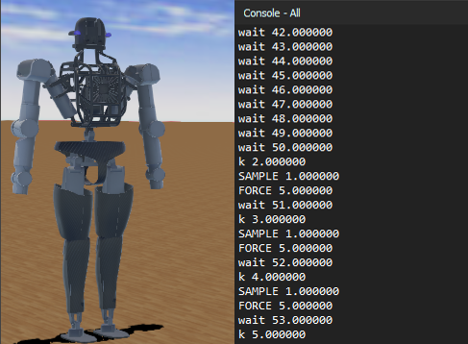
Figure 4. Applying Force of 5KN After Buffering

As the simulation runs properly, the sensor readings can be save in a matrix which is essential for creating the dataset needed for the classification to determine the magnitude of the applied force and its location. The matrix of all 28 sensor readings is appended every time a new sample is to be added after taking reading from a simulation after incrementing the force applied by a predefined force incrimination constant. And the same process repeats until a predefined limit is reached. At this point the simulator quits the application. In the next simulation the same process is experienced but the force will be applied on a different solid node or location and also with a different limit for the magnitude of the applied force making sure the robot will remain at its standing position all along the experiment. the flowchart below documents the program and helps in visualizing and understanding the process.
Figure 5. Data Collection Procedure

Dataset Formation

The controller that generate the preliminary dataset provides the following output; a matrix or arrays, were each array is a reading from a sensor. So each row represents a sample and each sample needs 28 arrays which are the reading from all 28 sensors to be represented. Each array fits in a column. Therefore, the matrix has 28 columns and the number of row depends on the number of samples collected. Besides the reading from the sensors, with each iteration 2 arrays will be filled; one filled with the magnitude of the force at each iteration and the other filled with the location at which the force was applied. It can be deduced that the generated dataset can be visualized as a cube.
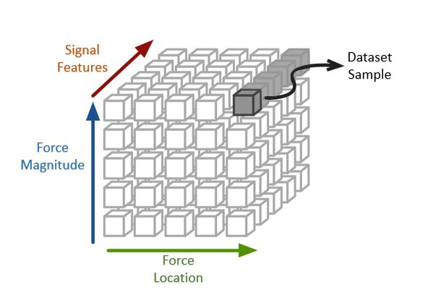
Figure 6. Three-Dimensional Dataset
As it can be seen in the figure above, the structure of the dataset is three-dimensional where every time a force is applies with a specific magnitude at a precise location a data sample can be fetched. This data sample is made of a combination of 27 arrays which are the readings from 27 sensors that describe the response of the humanoid under the disturbance. When adding a sample to the dataset, the aim is to add an observance that the computer will learn to enhance the control system of the humanoid robot. So an observance in which the humanoid loses stability completely should be excluded from the dataset. If a force at a specific location drives the vertical projection of the center of gravity of the humanoid out of the contact surface plane, the humanoid will lose stability. Excluding these samples, the dataset will no longer look like a perfect cube since each location can support the magnitude of the force to reach up to a certain range.
In this thesis, the work is going to be constrained to the selection of 6 locations on which the force can be applied on the center of gravity of the link, and instead of acquiring data from 27 sensors only 18 sensors located around the 6 selected locations on which a force can be applied will be considered. Some sensors are mounted on the robots to rotate in directions other than the x direction and in this thesis the force applied on the robot is always along the x direction. Therefore, such sensors can be excluded from the data acquisition set. The selected sensors and solid link nodes are listed in the tables below and can also be mapped on the figure using the tag numbers and characters.

Table 2. Selected Sesors
Parent Link | Number of Joints | Joints Names | Tag
Neck | 4 | - BackLbz  - BackMby  - BackUbx  - NeckAy | - 1  - 2  - 3  - 4
Left Arm | 3 | - LArmElx  - LArmMwx  - LArmUwy | - 5  - 6  - 7
Right Arm | 3 | - RArmElx  - RArmMwx  - RArmUwy | - 8  - 9  - 10
Left Leg | 4 | - LLegKny  - LLegLhy  - LLegMhx  - LLegUay | - 11  - 12  - 13  - 14
Right Leg | 4 | - RLegKny  - RLegLhy  - RLegMhx  - RLegUay | - 15  - 16  - 17  - 18

Table 3. Selected Solid Nodes
Solid Link Node Name | Tag
LScap | A
RScap | B
Pelvis | C
Torso | D
LLL | E
RLL | F

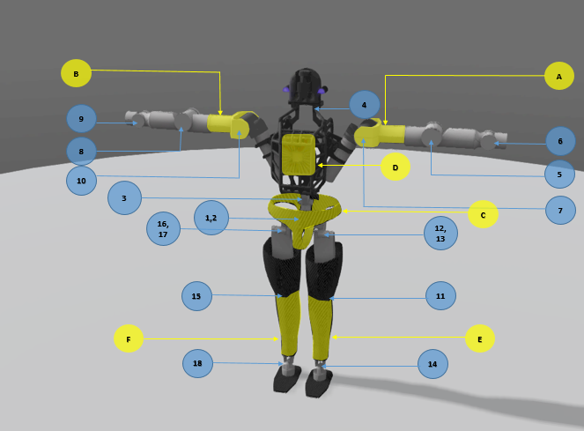
Figure 7. Distribution of Selected Sensors and Solid Nodes

After the selection of the needed sensors, the angle measurement at each joint can be measured and acquired by the controller and then the data is save in the workspace to be used and processed at a later stage. To shape a better idea of how a disturbance is affecting the humanoid, the sensor readings recorded of seven-second period of time can be plotted. The figures below demonstrate an example of the 18 sensor readings when the robot is not subject to any disturbance at all.

Figure 8. Sensor Readings without Disturbance in the Back and Neck Area
Figure 9. Sensor Readings without Disturbance in the Arms Area
Figure 10. Sensor Readings without Disturbance in the Legs Area
In the upcoming stage and after the data is collected, individual samples are plotted so that the effect of the disturbance on the robot can be clearly visualized by monitoring the variation at all joints. Similarly, a number of related samples are also taken together and plotted on the same graphs to observe how each sample is affecting the humanoid at all its joints differently and compare the results.

Feature Extraction
Having a dataset formed of sensor readings is an intermediary step. For the dataset to be ready to be used in a machine learning algorithm which will serve for the classification of the data and the detection of the force magnitude and location, the dataset must not contain samples of sets of sensor readings or signals. If the elements of the dataset are to be kept as signals, an alternative approach instead of having a machine learning algorithm would be measuring the similarity between the signals using the cross-correlation method. On the other hand, the method use in this thesis is the feature extraction method in which each signal of the 18 sensor readings is reduced to a set of measures. Each signal is to be processed and three features of this signal are extracted and used as measurements that can help in providing a unique identity of the curve. Therefore 18 sensor reading will be processed and 3 features will be extracted from each were the end result in an array of 54 features instead of having an array of 18 arrays.

A portion of the dataset was subjected to a test in which nine features were extracted from each signal in each sample. The output was analyzed for data samples in which the force is the same but acting on different locations to see which features are good indicators and also on data sample in which the force is acting at the same location but at different magnitudes.

Table 4. All Features and their Definitions
Feature | Definition
Mean | the average or the most common value in a collection of numbers
Standard Deviation | a statistic that measures the dispersion of a dataset relative to its mean
Mean Frequency | a spectrum is calculated as the sum of the product of the spectrogram intensity (in dB) and the frequency, divided by the total sum of spectrogram intensity
Variance | it is the average of the squared differences from the Mean
Skewness | a distortion or asymmetry that deviates from the symmetrical bell curve, or normal distribution, in a set of data
Kurtosis | the sharpness of the peak of a frequency-distribution curve
Maximum Value | the largest value
Minimal Value | the smallest value
Median | the middle number in a sorted, ascending or descending, list of numbers and can be more descriptive of that data set than the average

All nine features are ones usually used for feature extraction from sensor readings, but in this thesis and based on the testing results, the mean, standard deviation and mean frequency are the three best indicators of the applied force’s magnitude and position. In this case each reading from a sensor is going to be reduced to three features. Therefore, instead of having 18 sensor reading, the data sample will be formed of 54 features, three features from each sensor, and these 54 values represent the effect of the disturbance on the humanoid. As it was previously mentioned, the force applied on a different solid node or location have different limit for the magnitude of the applied force making sure the robot will remain at its standing position all along the experiment.

Table 5. Force Magnitude Limit at the Six Different Locations
Solid Link Node Name | Force magnitude Limit
LScap | 0 to 500 N
RScap | 0 to 500 N
Pelvis | 0 to 750 N
Torso | 0 to 750 N
LLL | 0 to 2000 N
RLL | 0 to 2000 N

It can be deduced that the dataset will not be shaped like a three-dimensional cube with equal side length; Horizontally six divisions representing the six different locations, vertically a number of samples incrementing the force form one sample to another by 5 N until the limit is reached. Exceeding the limit will cause the robot to loose stability and fall. Finally, the width of the three-dimensional dataset is 54 features for all samples.
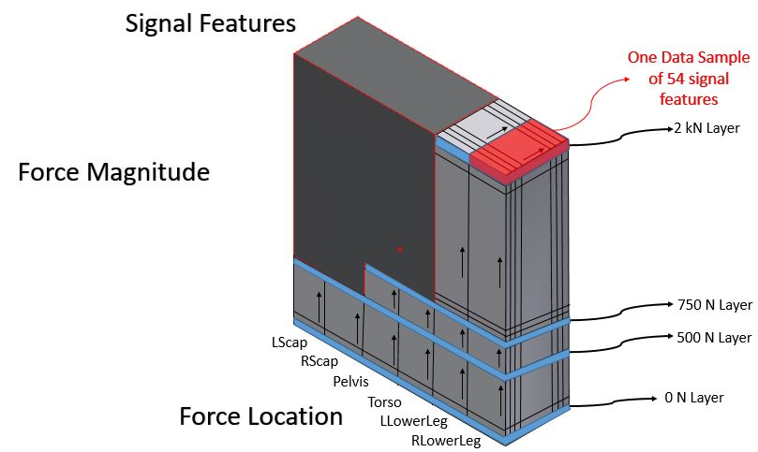
Figure 11. Dataset Visualization
An example of one data sample after the feature extraction can be described in the two following figures. First the data sample is represented by 18 sensor reading and after feature extraction it is represented by 54 features, three features extracted from each signal. The measurements of the 54 features in to be represented in a bar graph. It might be noticeable that four features are extracted but this is because sometimes the mean can have a negative value, so if the mean is negative it is plotted in a separate bar MN (Mean Negative) where the sign can be easily indicated by the color. The outputs in the two figures bellow is due to a 500 N force at the Torso.

Figure 12. 18 Sensor Readings for One Data Sample

Figure 13. 54 Features Extracted from 18 Sensor Readings

Machine Learning
As the dataset is generated and all features are extracted, all data samples are saves in a spreadsheet of 54 columns for the 54 signal features and two extra columns for the magnitude of the force and the location at which it was applied which are the desired output of this process. The process starts with finding the appropriate dataset containing the features required for the classification to happen. Before using the data, it all has to be manipulated and prepared. Next features and the response of the classifier have to be declared and then the dataset has the be divided into it is divided into two sets; the training dataset consists of 70% of the data and the testing dataset consisting of the remaining 30%. Both the training and the testing dataset are introduced the all algorithms and the results are compared. The algorithm classifying with the highest accuracy is the best algorithm to classify the data distributed as it is in this thesis.
When it comes to the classification of the data bates on the location, there are six classes for the data to be classified in. but when it comes to the force magnitude classification, there are 4001 classes which will definitely results in an under-fitting problem that can be solved by reducing the number of classes to nine by dividing the force magnitude observations into force magnitude rage. The total number of sample collected in the dataset in 1300 which is a number of samples enough to undergo a good classification procedure and expecting reliable results. Both classification problems for the force magnitude and the location are to be run alone.
There are numerous programs to use for such classification problems but in this thesis the MATLAB classification toolbox was used. So the dataset is loaded as a matrix of numbers. Next in the classification tool box the dataset is selected along with the features and also indicating the response which can be the force magnitude range or the location. The settings are also calibrated indicating the desired percentage to be taken for the testing and the training data. In the training phase, 70% of the dataset is taken along with the responses. Whereas in the testing phase 30% of the data is taken and classified based on the training that the algorithm has learned and the actual response is compared with the desired or expected response of the classification. Finally, the error and the accuracy are calculated to evaluate the performance of the algorithm and the results are all displayed in confusion matrices.

